TODO

Reference first quote in 2.2 The Game Design Process

Cite all images

Cite all references

Bibliography not showing references

COMPLETED – Declaration of Authorship

COMPLETED – Abstract

TODO – Acknowledgements

TODO – List of Figures

TODO – List of Tables

COMPLETED – 1 Introduction

Motivation

Contribution

Reference unity labs

Structure of This Document

Chapter 1

Chapter 2

Chapter 3

Chapter 4

Chapter 5

TODO – 2 Background

Thematic Area within Computer Science

Serious Games

Examples

Gamesforchange.org

Persuasive Games

Games for social change

Game Design

Where do ideas come from?

The MDA Framework

Mechanics

Dynamics

Aesthetics

1. Sensation - game as sense-pleasure  
2. Fantasy - game as make believe  
3. Narrative - game as drama  
4. Challenge - game as obstacle course  
5. Fellowship -game as social framework  
6. Discovery - game as uncharted territory  
7. Expression - game as self-discovery  
8. Submission - game as pastime

Prototyping

Paper-prototypeing

Wireframing

High-fidelity

Conceptual Game Characteristics

Genre

Rules

Balance

Perspective

Space

Focus and flow

Difficulty

Storytelling

Practical Game Characteristics

Game Loop

Dimensions

Physics

Controls

Graphics

Art

Level Design

Character Desisng

Music

A review of Unity

Scenes

Objects

Creating Primitive Objects

Scaling/rotating/moving objects

Materials

Scripts

A review of Blender

Literature on these areas

Rollable

Other lab

TODO – 3 Problem – rename to project title

Problem Definition

Creating a 3D video game using the Unity development platform with C#. The game will hope to include a movement system, items, inventory, equipable items, item containers (chests), player stats (health + stamina), enemy objects, combat system, unique 3d art using blender.

Objectives

What is the overall objective of the project. What do I produce as a final deliverable.

What the player experiences/does

SHOULD I REPLACE WHAT I HAVE FOR NON-FUNCTIONAL REQUIREMENTS HERE???

Functional Requirements

Character Objects

Player

Enemy

Friend

Character Statistics

Health

Stamina

Magic

Maximum carry capacity

Movement

Walking

Running

Sprinting

Rolling

Falling (raycasting)

Camera

Player movement

Environment collision

Items

Weapons

Armour

Consumables

Quest items

Combat

Inventory

Equipment

Item Containers

Compass

Set Markers

Animations

Animation blending

Animation masking

Sneaking

Unique 3d art

Quests

Ai -> Finite State Machines

https://www.youtube.com/watch?v=Vt8aZDPzRjI&t=770s

GAME STATE PERSISTENCE

Non-functional Requirements

Nonfunctional Requirements (NFRs) define system attributes such as security, reliability, performance, maintainability, scalability, and usability. They serve as constraints or restrictions on the design of the system across the different backlogs.

User friendly UI

Story via quest tutorial

Fun and interactive combat

TODO – 4 Implementation Approach

Architecture

Games Engine

Pre/post processing

Risk Assessment

Methodology

Agile

Monday.com board

Implementation Plan Schedule

Evaluation

Play testing

Quantitive

Qualitive

Prototype

Wireframes

Paper prototype

TODO – 5 Conclusions and Future Work

Discussion

Discussion on my research

Conclusion

Future Work

TODO - Bibliography

TODO – Code Snippets

TODO – Wireframe Models

References

2.2 The Game Design Process

Dieter RamsIndustrial Designe

Good design is making something intelligible and memorable, great design is making something memorable and meaningful.

2.2 The Game Design Process

<https://www.aaai.org/Papers/Workshops/2004/WS-04-04/WS04-04-001.pdf>

MDA: A Formal Approach to Game Design and Game Research

Robin Hunicke, Marc LeBlanc, Robert Zubek

one must first understand the idea that games are more like artifacts than media. By this we mean that the content of a game is its behavior ñ not the media that streams out of it towards the player. Thinking about games as designed artifacts helps frame them as systems that build behavior via interaction. It supports clearer design choices and analysis at all levels of study and development.

2.2 The Game Design Process

2.2.3 Paper-Prototyping

https://ieeexplore.ieee.org/abstract/document/5467312

The Blank-Page Technique: Reinvigorating Paper Prototyping in Usability Testing

[Brian Still](https://ieeexplore.ieee.org/author/37396840800); [John Morris](https://ieeexplore.ieee.org/author/37399308500)

Arguably, usability testing is most effective when integrated into the user-centered design process.

2.2 The Game Design Process

2.2.3 Paper-Prototyping

https://ieeexplore.ieee.org/abstract/document/5467312

The Blank-Page Technique: Reinvigorating Paper Prototyping in Usability Testing

[Brian Still](https://ieeexplore.ieee.org/author/37396840800); [John Morris](https://ieeexplore.ieee.org/author/37399308500)

Rather than occurring once, used as a quality-assurance tool to evaluate a “snapshot” of the product, it offers more positive feedback when employed as early and often as possible.

2.2.2 Mechanics, Dynamics and Aesthetics (MDA) framework

<https://www.aaai.org/Papers/Workshops/2004/WS-04-04/WS04-04-001.pdf>

MDA: A Formal Approach to Game Design and Game Research

Robin Hunicke, Marc LeBlanc, Robert Zubek

Systematic coherence comes when conflicting constraints are satisfied, and each of the gameís parts can relate to each other as a whole. Decomposing, understanding and creating this coherence requires travel between all levels of abstraction ñ fluent motion from systems and code, to content and play experience, and back.

2.2.2 Mechanics, Dynamics and Aesthetics (MDA) framework

https://www.sciencedirect.com/science/article/pii/S1877050918314765

Analysis of Gamification Models in Education Using MDA Framework

Gede PutraKusumaaEvan KristiaWigatibYesunUtomobLouis KhrisnaPutera Suryapranatac

Designers tend to see from Mechanics to Dynamics to Aesthetics, while players tend to see from Aesthetics to Dynamics to Mechanics.

2.2.2 Mechanics, Dynamics and Aesthetics (MDA) framework

<https://www.aaai.org/Papers/Workshops/2004/WS-04-04/WS04-04-001.pdf>

MDA: A Formal Approach to Game Design and Game Research

Robin Hunicke, Marc LeBlanc, Robert Zubek

From the designerís perspective, the mechanics give rise to dynamic system behavior, which in turn leads to particular aesthetic experiences. From the playerís perspective, aesthetics set the tone, which is born out in observable dynamics and eventually, operable mechanics.

2.2.2 Mechanics, Dynamics and Aesthetics (MDA) framework

<https://www.aaai.org/Papers/Workshops/2004/WS-04-04/WS04-04-001.pdf>

MDA: A Formal Approach to Game Design and Game Research

Robin Hunicke, Marc LeBlanc, Robert Zubek

Mechanics describes the particular components of the game, at the level of data rep-  
resentation and algorithms.

2.2.2 Mechanics, Dynamics and Aesthetics (MDA) framework

https://www.sciencedirect.com/science/article/pii/S1877050918314765

Analysis of Gamification Models in Education Using MDA Framework

Gede PutraKusumaaEvan KristiaWigatibYesunUtomobLouis KhrisnaPutera Suryapranatac

Mechanics describe rules or components implemented in games, such as basic action, algorithm, game engine, game elements, etc.

2.2.2 Mechanics, Dynamics and Aesthetics (MDA) framework

<https://www.aaai.org/Papers/Workshops/2004/WS-04-04/WS04-04-001.pdf>

MDA: A Formal Approach to Game Design and Game Research

Robin Hunicke, Marc LeBlanc, Robert Zubek

Dynamics describes the run-time behavior of the mechanics acting on player inputs and each othersí outputs over time.

2.2.2 Mechanics, Dynamics and Aesthetics (MDA) framework

https://www.researchgate.net/publication/326311784_Level_Up_Your_Strategy_Towards_a_Descriptive_Framework_for_Meaningful_Enterprise_Gamification

Level Up Your Strategy: Towards a Descriptive Framework forMeaningful Enterprise Gamification

Umar Ruhi

The context of the system establishes a cognitive anchoring point for players to recognize what types of activities they can undertake.

Ruhi U. Level Up Your Strategy: Towards a Descriptive Framework for Meaningful Enterprise Gamification. Technology Innovation

Management Review vol 5 issue 8. 2015;: p. 5-16

Dynamics are related to the game’s context, constraints, choices, chance,consequences, completion, continuation, competition, and cooperation

2.2.2 Mechanics, Dynamics and Aesthetics (MDA) framework

https://www.researchgate.net/publication/326311784_Level_Up_Your_Strategy_Towards_a_Descriptive_Framework_for_Meaningful_Enterprise_Gamification

Level Up Your Strategy: Towards a Descriptive Framework forMeaningful Enterprise Gamification

Umar Ruhi

Together, the dynamics of consequences, completion, and continuation establish the basis for a feedback sys-tem in gamification to help drive changes in end user behaviour.

2.2.2 Mechanics, Dynamics and Aesthetics (MDA) framework

<https://www.aaai.org/Papers/Workshops/2004/WS-04-04/WS04-04-001.pdf>

MDA: A Formal Approach to Game Design and Game Research

Robin Hunicke, Marc LeBlanc, Robert Zubek

Aesthetics Aesthetics describes the desirable emotional responses evoked in the player,  
when she interacts with the game system.

2.2.2 Mechanics, Dynamics and Aesthetics (MDA) framework

https://www.researchgate.net/publication/326311784_Level_Up_Your_Strategy_Towards_a_Descriptive_Framework_for_Meaningful_Enterprise_Gamification

Level Up Your Strategy: Towards a Descriptive Framework forMeaningful Enterprise Gamification

Umar Ruhi

End users formulate their experiences based on the aesthetics and they engage in specific activities towards satisfying their favoured gratifications.

2.2.2 Rules

https://game-studies.fandom.com/wiki/Game#:~:text=Jesper%20Juul%27s%20Classic%20Game%20Model&text=Fixed%20Rules,establishes%20a%20goal%20is%20understood)

In the second chapter of his book, Half Real: Video Games between Real Rules and Fictional Worlds, Jesper Juul compares multiple perspectives and definitions of game design and combines them into a formal definition he calls the "classic game model

2.2.2 Rules

https://is.cuni.cz/studium/predmety/index.php?do=download&did=27982&kod=JJM169

Half Real: Video Games between Real Rules and Fictional Worlds

Jesper Juul

2.2.6 Focus and Flow

https://books.google.ie/books?hl=en&lr=&id=6IyqCNBD6oIC&oi=fnd&pg=PA195&dq=Csikszentmihalyi%E2%80%99s+theory+of+flow&ots=INIdUDWbrA&sig=GHOyHna7nUrMq5g7Ir4PXyjBAbs&redir_esc=y#v=onepage&q=Csikszentmihalyi%E2%80%99s%20theory%20of%20flow&f=false

Flow and the Foundations of Positive Psychology

Mihaly Csikszentmihalyi

Flow is a state in which people are so involved in an activity that nothing else seems to matter; the experience is so enjoyable that people will continue to do it even at great cost, for the sheer sake of doing it.\cite{Reference13}

2.4.3 Physics

https://www.toptal.com/game/video-game-physics-part-i-an-introduction-to-rigid-body-dynamics#:~:text=A%20rigid%20body%20is%20like,sounds%2C%20especially%20in%20three%20dimensions.

Video Game Physics Tutorial - Part I: An Introduction to Rigid Body Dynamics

[**Nilson Souto**](https://www.toptal.com/resume/nilson-souto)

A rigid body is like an extension of a particle because it also has mass, position and velocity. Additionally, it has volume and shape, and so it can rotate

2.4.3 Physics

<https://perso.liris.cnrs.fr/nicolas.pronost/UUCourses/GamePhysics/lectures/lecture%204%20Rigid%20Body%20Physics.pdf>

Game Physics

Game and Media Technology

Master Program - Utrecht University

Dr. Nicolas Pronost

For a 3D object, the mass is therefore the integral over its volume along the three dimensions.

2.4.3 Physics

https://www.toptal.com/game/video-game-physics-part-i-an-introduction-to-rigid-body-dynamics#:~:text=A%20rigid%20body%20is%20like,sounds%2C%20especially%20in%20three%20dimensions.

Video Game Physics Tutorial - Part I: An Introduction to Rigid Body Dynamics

[**Nilson Souto**](https://www.toptal.com/resume/nilson-souto)

A rigid body naturally rotates around its Center Of Mass (COM), and the position of a rigid body is considered to be the position of its center of mass.

2.4.3 Physics

https://www.toptal.com/game/video-game-physics-part-ii-collision-detection-for-solid-objects

Video Game Physics Tutorial - Part II: Collision Detection for Solid Objects

[**Nilson Souto**](https://www.toptal.com/resume/nilson-souto)

Collision detection consists of finding pairs of bodies that are colliding among a possibly large number of bodies scattered around a 2D or 3D world.

2.4.3 Physics

https://www.toptal.com/game/video-game-physics-part-i-an-introduction-to-rigid-body-dynamics#:~:text=A%20rigid%20body%20is%20like,sounds%2C%20especially%20in%20three%20dimensions.

Video Game Physics Tutorial - Part II: Collision Detection for Solid Objects

[**Nilson Souto**](https://www.toptal.com/resume/nilson-souto)

In the context of rigid body simulations, a collision happens when the shapes of two rigid bodies are intersecting, or when the distance between these shapes falls below a small tolerance.

2.2.1 Genre

<https://journals.sfu.ca/loading/index.php/loading/article/view/67/105>

What Defines Video Game Genre? Thinking about Genre Study after the Great Divide

David A. Clearwater

However, the tendency to privilege player activity (or ‘gameplay,’ or ‘interactivity’) over all other aspects of a videogame has limited what some authors believe can be (or should be) included in the analysis of a single title or an entire genre.

2.2.1 Genre

<https://journals.sfu.ca/loading/index.php/loading/article/view/67/105>

What Defines Video Game Genre? Thinking about Genre Study after the Great Divide

David A. Clearwater

Indeed, the seemingly minor or secondary nature of non-gameplay elements has also led to questions concerning how interpretation and meaning are theorized with respect to interactive media.

<https://www.researchgate.net/figure/The-MDA-Framework-Perspectives-of-the-game-designer-and-the-player_fig8_265598960>

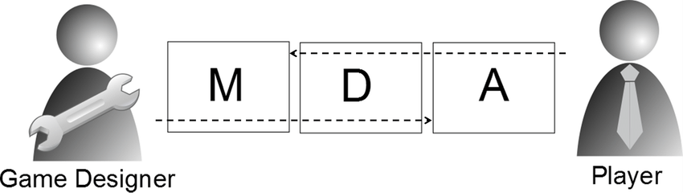

<https://www.youtube.com/watch?v=dt1bQsZ68iw>

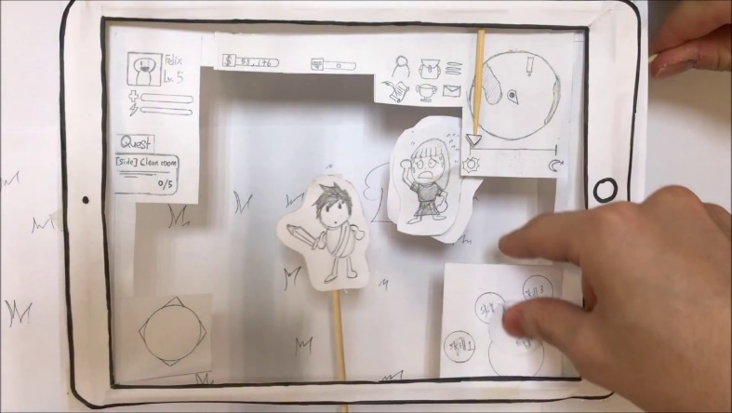

<http://www.cbcapone.com/wireframes.html>

<https://www.youtube.com/watch?v=T1RvF_gY28k>

